SCD Lab 03

Methods in Java

A Java method is a collection of statements that are grouped together to perform an operation. When you call the System.out.println () method, for example, the system actually executes several statements in order to display a message on the console. In this lab, you will learn how to create your own methods with or without return values, invoke a method with or without parameters, and apply method abstraction in the program design.
Creating Method

Syntax
public static int methodName(int a, int b) {
// body
}
Here,
- public static − modifier
- int − return type
- methodName − name of the method
- a, b − formal parameters
- int a, int b − list of parameters

Method definition consists of a method header and a method body.
Syntax
modifier returnType nameOfMethod (Parameter List) {
// method body
}
Here,
- Modifier − It defines the access type of the method and it is optional to use.
- returnType − Method may return a value.
- nameOfMethod −This is the method name. The method signature consists of the method name and the parameter list.
- Parameter List − the list of parameters, it is the type, order, and number of parameters of a method. These are optional, method may contain zero parameters.
- Method body − the method body defines what the method does with the statements.

Example 01
Source code of the above defined method called min(). This method takes two parameters num1 and num2 and returns the maximum between the two −
/** the snippet returns the minimum between two numbers */

public static int minFunction(int n1, int n2) {
int min;
if (n1 > n2)
min = n2;
else
min = n1;

return min;
}

Method Calling
For using a method, it should be called. There are two ways in which a method is called i.e., method returns a value or returning nothing (no return value).
The methods returning void is considered as call to a statement. For example −
System.out.println("This is IET-OOP Lab!");
The method returning value can be understood by the following example −
int result = sum(6, 9);

Following is the example to demonstrate how to define a method and how to call it −
Example 02

public class ExampleMinNumber {

public static void main(String[] args) {
int a = 11;
int b = 6;
int c = minFunction(a, b);
System.out.println("Minimum Value = " + c);
}

/** returns the minimum of two numbers */
public static int minFunction(int n1, int n2) {
int min;
if (n1 > n2)
min = n2;
else
min = n1;

return min;
}
}

This will produce the following result −
Output
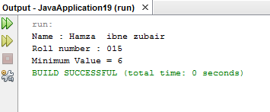

The void Keyword
The void keyword allows us to create methods which do not return a value.
Example 03
public class ExampleVoid {

public static void main(String[] args) {
methodRankPoints(255.7);
}

public static void methodRankPoints(double points) {
if (points >= 202.5) {
System.out.println("Rank:A1");
}else if (points >= 122.4) {
System.out.println("Rank:A2");
}else {
System.out.println("Rank:A3");
}
}
}
This will produce the following result −
Output
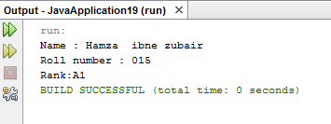

Passing Parameters by Value
While working under calling process, arguments is to be passed. These should be in the same order as their respective parameters in the method specification. Parameters can be passed by value or by reference.
Passing Parameters by Value means calling a method with a parameter. Through this, the argument value is passed to the parameter.

Example 04
The following program shows an example of passing parameter by value.
public class swappingExample {

public static void main(String[] args) {
int a = 30;
int b = 45;
System.out.println("Before swapping, a = " + a + " and b = " + b);

// Invoke the swap method
swapFunction(a, b);
System.out.println("\n**Now, Before and After swapping values will be same here**:");
System.out.println("After swapping, a = " + a + " and b is " + b);
}

public static void swapFunction(int a, int b) {
System.out.println("Before swapping(Inside), a = " + a + " b = " + b);

// Swap n1 with n2
int c = a;
a = b;
b = c;
System.out.println("After swapping(Inside), a = " + a + " b = " + b);
}
}
This will produce the following result −
Output
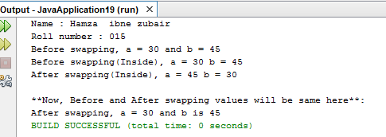

Method Overloading
When a class has two or more methods by the same name but different parameters, it is known as method overloading. It is different from overriding. In overriding, a method has the same method name, type, number of parameters, etc.
Let’s consider the example for finding minimum numbers of integer type. If, let’s say we want to find the minimum number of double type. Then the concept of overloading will be introduced to create two or more methods with the same name but different parameters.
The following example explains the same −
Example 05
public class ExampleOverloading {

public static void main(String[] args) {
int a = 11;
int b = 6;
double c = 7.3;
double d = 9.4;
int result1 = minFunction(a, b);

// same function name with different parameters
double result2 = minFunction(c, d);
System.out.println("Minimum Value = " + result1);
System.out.println("Minimum Value = " + result2);
}

// for integer
public static int minFunction(int n1, int n2) {
int min;
if (n1 > n2)
min = n2;
else
min = n1;

return min;
}

// for double
public static double minFunction(double n1, double n2) {
double min;
if (n1 > n2)
min = n2;
else
min = n1;

return min;
}
}
This will produce the following result −
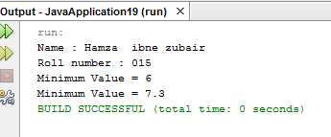
Output

Using Command-Line Arguments
Sometimes you will want to pass some information into a program when you run it. This is accomplished by passing command-line arguments to main ( ).
A command-line argument is the information that directly follows the program's name on the command line when it is executed. To access the command-line arguments inside a Java program is quite easy. They are stored as strings in the String array passed to main ( ).
Example 06
The following program displays all of the command-line arguments that it is called with “−”
public class CommandLine {

public static void main(String args[]) {
for(int i = 0; i<args.length; i++) {
System.out.println("args[" + i + "]: " + args[i]);
}
}
}
Try executing this program as shown here −
$java CommandLine this is a command line 200 -100
This will produce the following result −
Output
args[0]: this
args[1]: is
args[2]: a
args[3]: command
args[4]: line
args[5]: 200
args[6]: -100

The this keyword
This is a keyword in Java which is used as a reference to the object of the current class, with in an instance method or a constructor. Using this you can refer the members of a class such as constructors, variables and methods.
Note − the keyword this is used only within instance methods or constructors
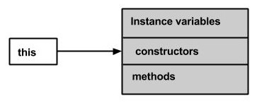
In general, the keyword this is used to −
- Differentiate the instance variables from local variables if they have same names, within a constructor or a method.
class Student {
int age;
Student(int age) {
this.age = age;
}
}
- Call one type of constructor (parametrized constructor or default) from other in a class. It is known as explicit constructor invocation.
class Student {
int age
Student() {
this(20);
}

Student(int age) {
this.age = age;
}
}

Example 07
Uses this keyword to access the members of a class.
public class This_Example {
// Instance variable num
int num = 10;

This_Example() {
System.out.println("This is an example program on keyword this");
}

This_Example(int num) {
// Invoking the default constructor
this();

// Assigning the local variable num to the instance variable num
this.num = num;
}

public void greet() {
System.out.println("Hi Welcome to IETOOP Lab");
}

public void print() {
// Local variable num
int num = 20;

// Printing the local variable
System.out.println("value of local variable num is : "+num);

// Printing the instance variable
System.out.println("value of instance variable num is : "+this.num);

// Invoking the greet method of a class
this.greet();
}

public static void main(String[] args) {
// Instantiating the class
This_Example obj1 = new This_Example();

// Invoking the print method
obj1.print();

// Passing a new value to the num variable through parametrized constructor
This_Example obj2 = new This_Example(30);

// Invoking the print method again
obj2.print();
}
}

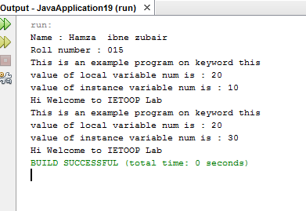
This will produce the following result −
Output

The finalize( ) Method
It is possible to define a method that will be called just before an object's final destruction by the garbage collector. This method is called finalize ( ), and it can be used to ensure that an object terminates cleanly.
For example, you might use finalize( ) to make sure that an open file owned by that object is closed.
Syntax
protected void finalize( ) {
// finalization code here
}

Example 08
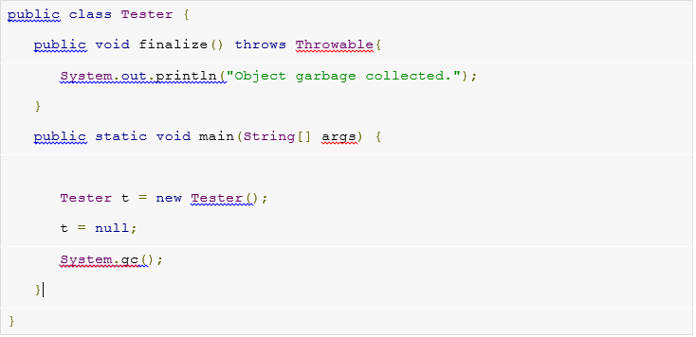
This will produce the following result −
Output

Lab Exercise:

- Write a program to demonstrate static variables, methods, and blocks.

- Write a program to give the example for method overloading.

public class ExampleOverloading {

public static void main(String[] args) {
int a = 11;
int b = 6;
double c = 7.3;
double d = 9.4;
int result1 = minFunction(a, b);

// same function name with different parameters
double result2 = minFunction(c, d);
System.out.println("Name : Hamza ibne zubair\nRoll number : 015" );
System.out.println("Minimum Value = " + result1);
System.out.println("Minimum Value = " + result2);
}

// for integer
public static int minFunction(int n1, int n2) {
int min;
if (n1 > n2)
min = n2;
else
min = n1;

return min;
}

// for double
public static double minFunction(double n1, double n2) {
double min;
if (n1 > n2)
min = n2;
else
min = n1;

return min;
}
}
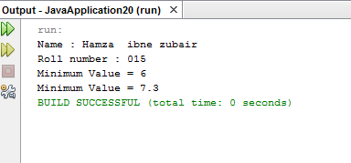

- Write a program to give the example for ‘super’ keyword.
package superclass;
public class Superclass {

public void sms(){
System.out.println("Parent hello");
}

}
class Child extends Superclass{
public void sms(){
System.out.println("Child hello");

}
public void msg(){
sms();
super.sms();
}
}
class test{
public static void main(String[] args) {
Child c=new Child();
System.out.println("Name : Hamza ibne zubair\nRoll number : 015" );
c.msg();

}

}
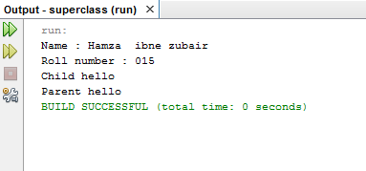

- Write a Java method to find the smallest number among three numbers.

package small;

public class Small {
public void small(int a,int b,int c){
if(a>b&&a>c){
System.out.println("Greater number is "+a);
}
else if(b>a&&b>c){
System.out.println("Greater number is "+b);
}
else if(c>a&&c>b){
System.out.println("Greater number is "+c);
}
else{
System.out.println("Numbers a re equal");
}
}
}

class test{

public static void main(String[] args) {
int a,b,c;
Small s=new Small();
s.small(1, 2, 3);
}

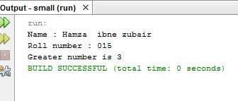
}

- Write a Java method to display the middle character of a string.
a) If the length of the string is odd there will be two middle characters.
b) If the length of the string is even there will be one middle character
- Write a Java method to check whether a year (integer) entered by the user is a leap year or not.

package year;
import java.util.Scanner;

public class Year {
public void year(int y){
if (y%4==0){
System.out.println("Leap year");
}
else{
System.out.println("Not a Leap year");
}
}
}
class test{
public static void main(String[] args) {
Scanner input=new Scanner(System.in);

int year;
System.out.println("Name : Hamza ibne zubair\nRoll number : 015" );
System.out.println("Enter year");
year=input.nextInt();
Year y=new Year();
y.year(year);

}

}

